**Report 2 : MySQL 모델링** – 20175288 최광삼



1. relation scheme

1.1 Entity relations :

**AIRPORT** (Airport_code, City, State, Name)

**AIRPLANE_TYPE** (Type_name, Max_seats, Company)

**AIRPLANE** (Airplane_id, Total_no_of_seats, Type_name* NN)

**FLIGHT** (Number, Airline, Weekdays)

1.2 Entity relations (existential dependency) :

**FARE** (Flight_Number*, Code, Amount, Restrictions)

**FLIGHT_LEG** (Flight_Number*, Leg_no, DEP_Airport_code* NN, ARR_Airport_code* NN, Scheduled_dep_time, Scheduled_arr_time)

**LEG_INSTANCE** (Flight_Number*, Leg_no*, Date, No_of_avail_seats, Airplane_id* NN, DEP_Airport_code*, ARR_Airport_code*, Dep_time, Arr_time)

**SEAT** (Flight_Number*, Leg_no*, Date*, Seat_no, Customer_name, Cphone)

1.3 Relationship relations :

**CAN_LAND** (Airport_code*, Type_name*)

1.4 Attribute relations (multi valued) : 없음

2. EER 다이어그램

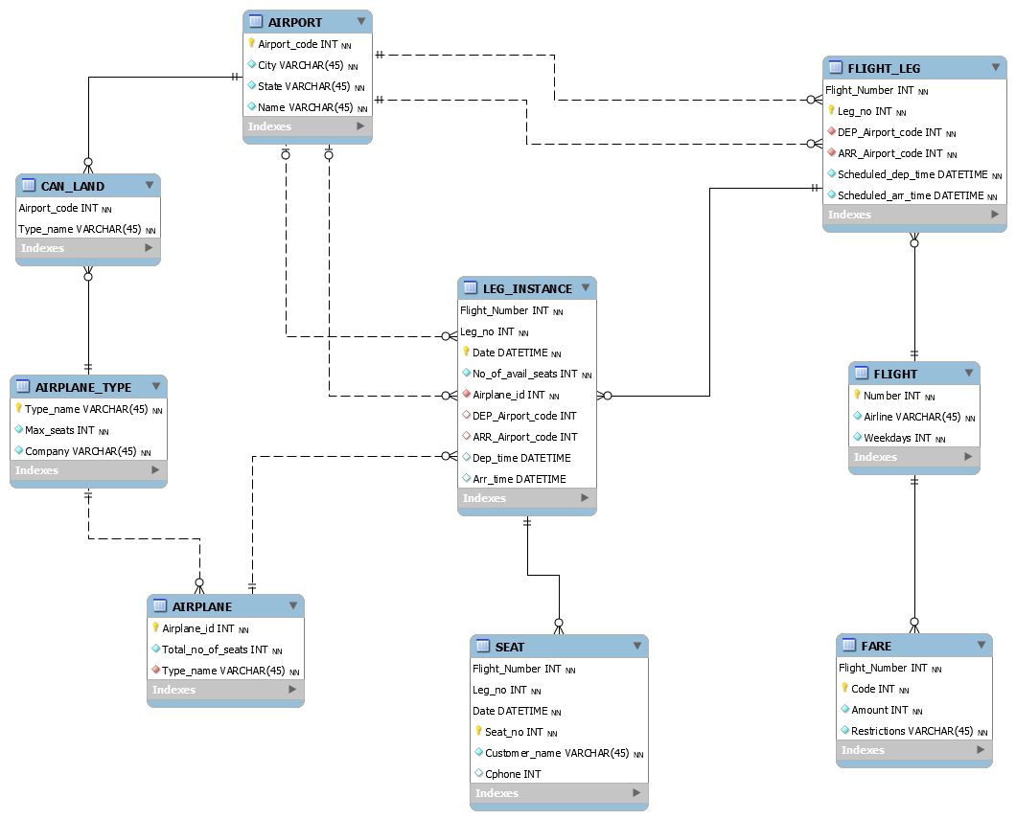

3. DDL script

-- MySQL Script generated by MySQL Workbench

-- Thu Apr 23 22:51:29 2020

-- Model: New Model Version: 1.0

-- MySQL Workbench Forward Engineering

SET @OLD_UNIQUE_CHECKS=@@UNIQUE_CHECKS, UNIQUE_CHECKS=0;

SET @OLD_FOREIGN_KEY_CHECKS=@@FOREIGN_KEY_CHECKS, FOREIGN_KEY_CHECKS=0;

SET @OLD_SQL_MODE=@@SQL_MODE, SQL_MODE='ONLY_FULL_GROUP_BY,STRICT_TRANS_TABLES,NO_ZERO_IN_DATE,NO_ZERO_DATE,ERROR_FOR_DIVISION_BY_ZERO,NO_ENGINE_SUBSTITUTION';

-- -----------------------------------------------------

-- Schema AIRLINE_RESERVATION

-- -----------------------------------------------------

-- -----------------------------------------------------

-- Schema AIRLINE_RESERVATION

-- -----------------------------------------------------

CREATE SCHEMA IF NOT EXISTS `AIRLINE_RESERVATION` DEFAULT CHARACTER SET utf8 ;

USE `AIRLINE_RESERVATION` ;

-- -----------------------------------------------------

-- Table `AIRLINE_RESERVATION`.`AIRPORT`

-- -----------------------------------------------------

CREATE TABLE IF NOT EXISTS `AIRLINE_RESERVATION`.`AIRPORT` (

`Airport_code` INT NOT NULL,

`City` VARCHAR(45) NOT NULL,

`State` VARCHAR(45) NOT NULL,

`Name` VARCHAR(45) NOT NULL,

PRIMARY KEY (`Airport_code`))

ENGINE = InnoDB;

-- -----------------------------------------------------

-- Table `AIRLINE_RESERVATION`.`FLIGHT`

-- -----------------------------------------------------

CREATE TABLE IF NOT EXISTS `AIRLINE_RESERVATION`.`FLIGHT` (

`Number` INT NOT NULL,

`Airline` VARCHAR(45) NOT NULL,

`Weekdays` INT NOT NULL,

PRIMARY KEY (`Number`))

ENGINE = InnoDB;

-- -----------------------------------------------------

-- Table `AIRLINE_RESERVATION`.`FLIGHT_LEG`

-- -----------------------------------------------------

CREATE TABLE IF NOT EXISTS `AIRLINE_RESERVATION`.`FLIGHT_LEG` (

`Flight_Number` INT NOT NULL,

`Leg_no` INT NOT NULL,

`DEP_Airport_code` INT NOT NULL,

`ARR_Airport_code` INT NOT NULL,

`Scheduled_dep_time` DATETIME NOT NULL,

`Scheduled_arr_time` DATETIME NOT NULL,

PRIMARY KEY (`Flight_Number`, `Leg_no`),

INDEX `FK_FLIGHT_FLIGHT_LEG` (`Flight_Number` ASC) VISIBLE,

INDEX `FK_DEPARTURE_FLIGHT` (`DEP_Airport_code` ASC) VISIBLE,

INDEX `FK_ARRIVAL_FLIGHT` (`ARR_Airport_code` ASC) VISIBLE,

CONSTRAINT `FK_FLIGHT_FLIGHT_LEG`

FOREIGN KEY (`Flight_Number`)

REFERENCES `AIRLINE_RESERVATION`.`FLIGHT` (`Number`)

ON DELETE NO ACTION

ON UPDATE NO ACTION,

CONSTRAINT `FK_DEPARTURE_FLIGHT`

FOREIGN KEY (`DEP_Airport_code`)

REFERENCES `AIRLINE_RESERVATION`.`AIRPORT` (`Airport_code`)

ON DELETE NO ACTION

ON UPDATE NO ACTION,

CONSTRAINT `FK_ARRIVAL_FLIGHT`

FOREIGN KEY (`ARR_Airport_code`)

REFERENCES `AIRLINE_RESERVATION`.`AIRPORT` (`Airport_code`)

ON DELETE NO ACTION

ON UPDATE NO ACTION)

ENGINE = InnoDB;

-- -----------------------------------------------------

-- Table `AIRLINE_RESERVATION`.`AIRPLANE_TYPE`

-- -----------------------------------------------------

CREATE TABLE IF NOT EXISTS `AIRLINE_RESERVATION`.`AIRPLANE_TYPE` (

`Type_name` VARCHAR(45) NOT NULL,

`Max_seats` INT NOT NULL,

`Company` VARCHAR(45) NOT NULL,

PRIMARY KEY (`Type_name`))

ENGINE = InnoDB;

-- -----------------------------------------------------

-- Table `AIRLINE_RESERVATION`.`AIRPLANE`

-- -----------------------------------------------------

CREATE TABLE IF NOT EXISTS `AIRLINE_RESERVATION`.`AIRPLANE` (

`Airplane_id` INT NOT NULL,

`Total_no_of_seats` INT NOT NULL,

`Type_name` VARCHAR(45) NOT NULL,

PRIMARY KEY (`Airplane_id`),

INDEX `FK_TYPE_AIRPLANE` (`Type_name` ASC) VISIBLE,

CONSTRAINT `FK_TYPE_AIRPLANE`

FOREIGN KEY (`Type_name`)

REFERENCES `AIRLINE_RESERVATION`.`AIRPLANE_TYPE` (`Type_name`)

ON DELETE NO ACTION

ON UPDATE NO ACTION)

ENGINE = InnoDB;

-- -----------------------------------------------------

-- Table `AIRLINE_RESERVATION`.`FARE`

-- -----------------------------------------------------

CREATE TABLE IF NOT EXISTS `AIRLINE_RESERVATION`.`FARE` (

`Flight_Number` INT NOT NULL,

`Code` INT NOT NULL,

`Amount` INT NOT NULL,

`Restrictions` VARCHAR(45) NOT NULL,

PRIMARY KEY (`Flight_Number`, `Code`),

INDEX `FK_FLIGHT_FARE` (`Flight_Number` ASC) VISIBLE,

CONSTRAINT `FK_FLIGHT_FARE`

FOREIGN KEY (`Flight_Number`)

REFERENCES `AIRLINE_RESERVATION`.`FLIGHT` (`Number`)

ON DELETE NO ACTION

ON UPDATE NO ACTION)

ENGINE = InnoDB;

-- -----------------------------------------------------

-- Table `AIRLINE_RESERVATION`.`CAN_LAND`

-- -----------------------------------------------------

CREATE TABLE IF NOT EXISTS `AIRLINE_RESERVATION`.`CAN_LAND` (

`Airport_code` INT NOT NULL,

`Type_name` VARCHAR(45) NOT NULL,

PRIMARY KEY (`Airport_code`, `Type_name`),

INDEX `FK_CAN_LAND_AIRPLANE_TYPE` (`Type_name` ASC) VISIBLE,

CONSTRAINT `FK_CAN_LAND_AIRPORT`

FOREIGN KEY (`Airport_code`)

REFERENCES `AIRLINE_RESERVATION`.`AIRPORT` (`Airport_code`)

ON DELETE NO ACTION

ON UPDATE NO ACTION,

CONSTRAINT `FK_CAN_LAND_AIRPLANE_TYPE`

FOREIGN KEY (`Type_name`)

REFERENCES `AIRLINE_RESERVATION`.`AIRPLANE_TYPE` (`Type_name`)

ON DELETE NO ACTION

ON UPDATE NO ACTION)

ENGINE = InnoDB;

-- -----------------------------------------------------

-- Table `AIRLINE_RESERVATION`.`LEG_INSTANCE`

-- -----------------------------------------------------

CREATE TABLE IF NOT EXISTS `AIRLINE_RESERVATION`.`LEG_INSTANCE` (

`Flight_Number` INT NOT NULL,

`Leg_no` INT NOT NULL,

`Date` DATETIME NOT NULL,

`No_of_avail_seats` INT NOT NULL,

`Airplane_id` INT NOT NULL,

`DEP_Airport_code` INT NULL,

`ARR_Airport_code` INT NULL,

`Dep_time` DATETIME NULL,

`Arr_time` DATETIME NULL,

PRIMARY KEY (`Flight_Number`, `Leg_no`, `Date`),

INDEX `FK_DEPARTS_INSTANCE` (`DEP_Airport_code` ASC) VISIBLE,

INDEX `FK_ARRIVES_INSTANCE` (`ARR_Airport_code` ASC) VISIBLE,

INDEX `FK_FLIGHT_LEG_INSTANCE` (`Flight_Number` ASC, `Leg_no` ASC) INVISIBLE,

INDEX `FK_ASSIGNED_INSTANCE` (`Airplane_id` ASC) VISIBLE,

CONSTRAINT `FK_DEPARTS_INSTANCE`

FOREIGN KEY (`DEP_Airport_code`)

REFERENCES `AIRLINE_RESERVATION`.`AIRPORT` (`Airport_code`)

ON DELETE NO ACTION

ON UPDATE NO ACTION,

CONSTRAINT `FK_ARRIVES_INSTANCE`

FOREIGN KEY (`ARR_Airport_code`)

REFERENCES `AIRLINE_RESERVATION`.`AIRPORT` (`Airport_code`)

ON DELETE NO ACTION

ON UPDATE NO ACTION,

CONSTRAINT `FK_FLIGHT_LEG_INSTANCE`

FOREIGN KEY (`Flight_Number` , `Leg_no`)

REFERENCES `AIRLINE_RESERVATION`.`FLIGHT_LEG` (`Flight_Number` , `Leg_no`)

ON DELETE NO ACTION

ON UPDATE NO ACTION,

CONSTRAINT `FK_ASSIGNED_INSTANCE`

FOREIGN KEY (`Airplane_id`)

REFERENCES `AIRLINE_RESERVATION`.`AIRPLANE` (`Airplane_id`)

ON DELETE NO ACTION

ON UPDATE NO ACTION)

ENGINE = InnoDB;

-- -----------------------------------------------------

-- Table `AIRLINE_RESERVATION`.`SEAT`

-- -----------------------------------------------------

CREATE TABLE IF NOT EXISTS `AIRLINE_RESERVATION`.`SEAT` (

`Flight_Number` INT NOT NULL,

`Leg_no` INT NOT NULL,

`Date` DATETIME NOT NULL,

`Seat_no` INT NOT NULL,

`Customer_name` VARCHAR(45) NOT NULL,

`Cphone` INT NULL,

PRIMARY KEY (`Flight_Number`, `Leg_no`, `Date`, `Seat_no`),

INDEX `FK_RESERVATION_SEAT` (`Flight_Number` ASC, `Leg_no` ASC, `Date` ASC) INVISIBLE,

CONSTRAINT `FK_RESERVATION_SEAT`

FOREIGN KEY (`Flight_Number` , `Leg_no` , `Date`)

REFERENCES `AIRLINE_RESERVATION`.`LEG_INSTANCE` (`Flight_Number` , `Leg_no` , `Date`)

ON DELETE NO ACTION

ON UPDATE NO ACTION)

ENGINE = InnoDB;

SET SQL_MODE=@OLD_SQL_MODE;

SET FOREIGN_KEY_CHECKS=@OLD_FOREIGN_KEY_CHECKS;

SET UNIQUE_CHECKS=@OLD_UNIQUE_CHECKS;

4. SqlDBM 다이어그램

